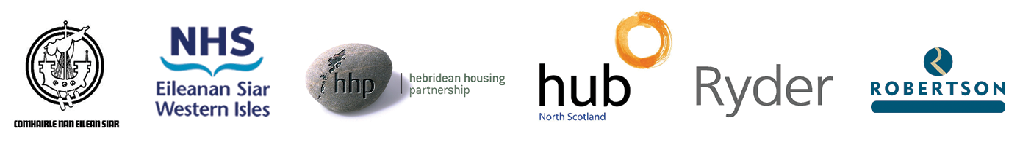

Barra and Vatersay Community Campus
Consultation Feedback Form

We value your feedback and would be grateful if you could complete the following questions.

1. | What is your overall impression of the proposals? (Please mark an x in the box below)
Very supportive |  |  | Supportive |  |  | Neutral |  | Not supportive
2. | Which elements of the proposals appeal to you?
3. | Are there any elements of the proposals that do not appeal to you?
4. | Is there anything you would like to see in the proposals that are not already included?
5. | How informative have you found the public consultation?  (Please mark an x in the box below)
Very informative |  |  |  | Informative |  | Neutral |  |  | Not informative
6. | Please provide any additional comments you would like to make in the space below
7. | Details  (Please mark an x in the box below)
Age 16-25 |  | Age 26-35 |  |  | Age 36-45 | Age 46-55 | Age 56-65 |  |  | Age 66+

Please return by 24 June 2022 to: Barra and Vatersay Community Campus Consultation,
Comhairle nan Eilean Siar, Council Offices, Castlebay, Isle of Barra, HS9 5XD or email to: investmentdelivery@cne-siar.gov.uk Thank you for your time.

